**Networked File Sharing Server and Client**

1. **Low-Level Design (LLD) : *Flowchart***
2. **Server**

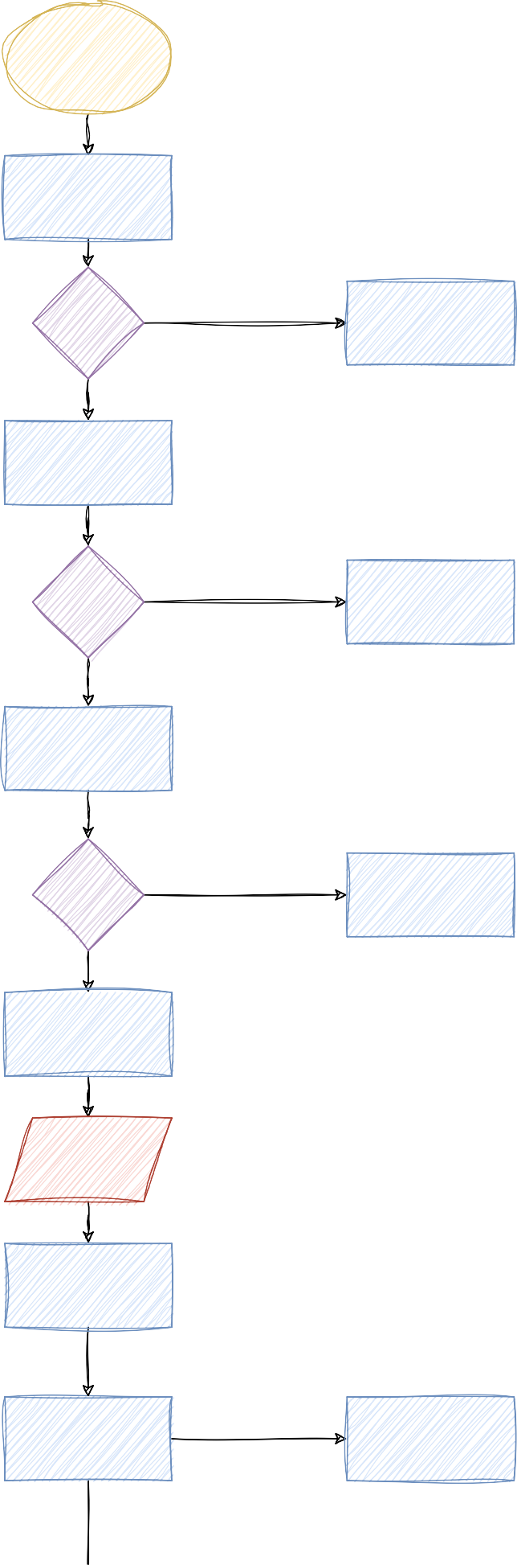

Start Server

Create a server socket

Socket Creation?

fails

Print error and exit

pass

Bind the server socket to an IP and

PORT pass

fails

Binding?

Print error and exit

pass

Listen for Incoming connections

pass

fails

Listening?

Print error and exit

Print "Sever listening to PORT No. 8080

Accept Client Connect Loop

Accept anclient

connection

fails

Accepting?

Print error and exit

pass

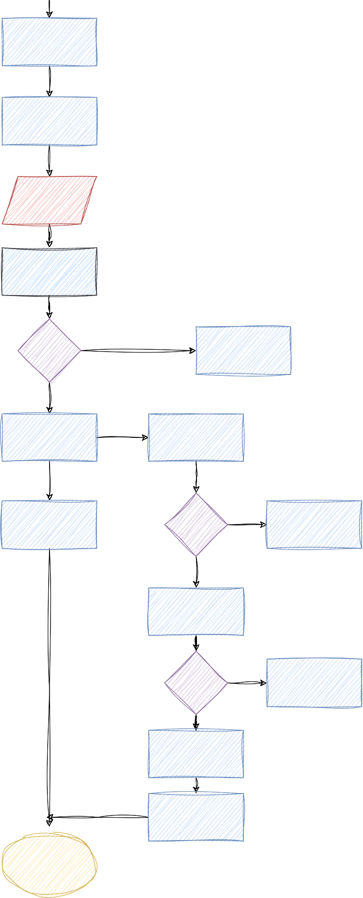

Print " Client connected from IP"

Create thread to handle client using handle Client function

Handle Client Function(Thread)

Receive data from client

fails

Received data ?

Print error and exit

pass

Received data is FILE_START

Open a file for writing

Print "Message from client "

fails

File opening?

Print error and exit

pass

Print "Receiving file from client "

Received data

Received data is "FILE_END"

: break

Write data to file and close the file.

Print "File received successfully”

Close client socket

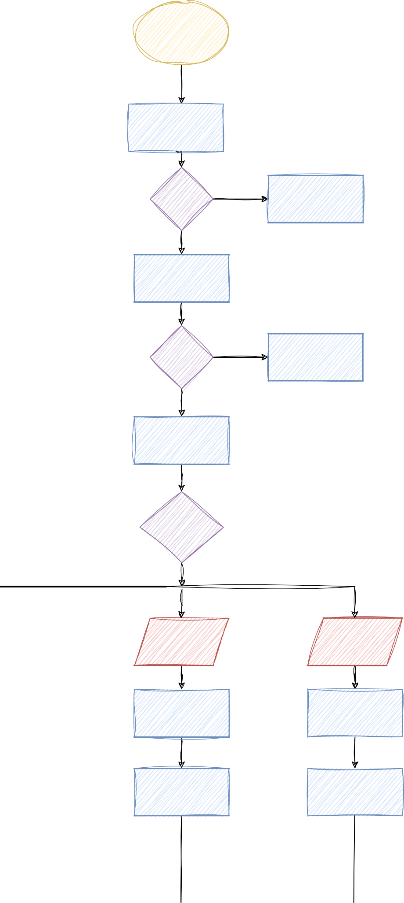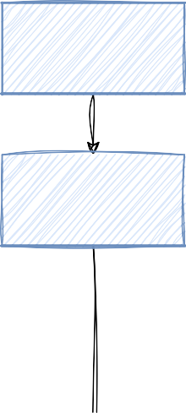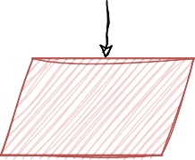

1. **Low-Level Design (LLD) : *Flowchart***
2. **Client**

Start Client

Create a client socket

Socket fails

Creation? Print error and exit

pass

Connect to the Server

fails

Connection ? Print error and exit

pass

Use Iteration Loop

Prompt user

for

**' file ', 'message', ' exit '**

If Input is ' file '

If Input is

' message '

If Input is ' exit '

Prompt for file path / filename

Prompt for message

Print " Exiting and break loop

Send "FILE_START"

to server

Send message for the

server

Print "Invalid option"

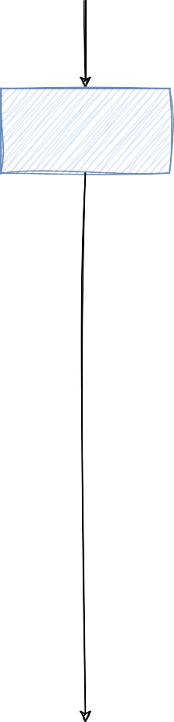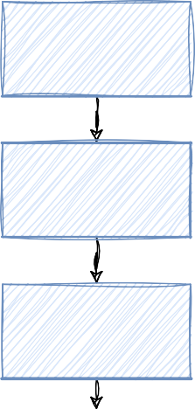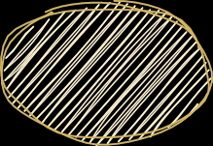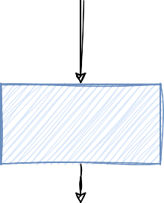

Open file for reading

Print message send

fails

Opening?

Print error and continue

pass

While Reading data Send data to

' SERVER '

Send "FILE_END" to the SERVER

Print "File send successfully"

Close client socket

1. **Low-Level Design (LLD) : *Flowchart***
2. **Integrated Server and Client**

